Erica Eis
LIS 590 YRL
15 July 2015
Reader’s Advisory Assignment
Approach: I chose to assist Matthew’s poor Mom, who is desperate to read about anything besides dinosaurs. I picked this hypothetical because I had mixed feelings about it. One the one hand, I was initially frustrated because if Matthew is excited about dinosaurs, shouldn’t we (Mom, librarians, teachers, etc.) use that enthusiasm to motivate his reading? On the other hand, at some point Matthew will have to read about non-dinosaur topics. Ultimately, I approached this hypothetical with the question: Which patron am I serving? I decided to try and serve both Mom and Matthew. You won’t find a dinosaur book on my list, but you will find some cool animals reminiscent of dinosaurs. I selected both nonfiction and fiction titles because I wanted to provide Mom with a variety of genres. Who knows which genre or subject Matthew will like? Let’s give him a lot of fun and interesting reading options, especially since we’re trying to get him excited about the world outside of dinosaur-land.

Nonfiction Titles

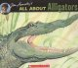 | All About Alligators by Jim Arnosky (1994) Scholastic Inc.  ATOS level/AR points: 5.2/.5  Lexile: 770L  Qualitative Measure: The text structure is moderately complex, there are many supplementary illustrations and descriptions, which could be difficult for Matthew to navigate without a more experienced reader to guide him. The language, purpose, and knowledge demands are slightly complex. Overall, the layout of the pages are inconsistent and could be confusing for Matthew, causing me to view this as a moderately complex text for him.  My thoughts: Although this book is a bit advanced for Matthew, I think it would be a good book to read with Mom, especially because the language isn’t too complex and the book has TONS of information about alligators. Because the text structure and layout is complex but other features aren't as complex, this book would be great for Mom to read to Matthew, pointing out familiar words and which images go with which text.
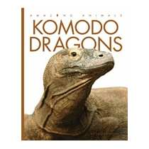 | Komodo Dragons by Valerie Bodden (2013) Creative Education  ATOS level/AR points: 2.9/.5  Lexile: 590L  Qualitative Measure: In general, the book is slightly complex to moderately complex (particularly because of all the foreign topics/information). Sentences are grammatically simple and each page contains one paragraph on one topic.  My thoughts: This was the first book I picked, because it has large, beautiful photographs for Matthew to examine while Mom reads the text. Also, I liked that the font was large and keywords are bolded, providing opportunities for Matthew to easily try and read along with Mom and for Mom to point out keywords and explain them. Also, each bold keyword is defined on the same page at the bottom of the page! Great! Also, if Mom and Matthew like this book, it’s part of a series (Amazing Animals) with each book examining a different animal.
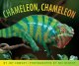 | Chameleon, Chameleon by Joy Cowley (2005) Scholastic Press  ATOS level/AR points: 3.0/.5  Lexile: 180L or AD310L  Qualitative Measure: Slightly complex, although the text is not in a consistent location, which may confuse Matthew should he try to read this book alone without a guiding reader.  My thoughts: The best part of this book is the photographs, which complement the simple text perfectly. I also think that this would be a great book for Matthew to try to read (with Mom’s guidance). Although there are some big words, there are not very many words per page, and the text is not complex.
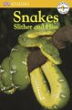 | Snakes Slither and Hiss by Fiona Lock (2008) DK Publishing  ATOS level/AR points: 1.2/.5  Lexile: Not found?  Qualitative Measure: Slightly Complex, with several repeated words and phrases and one sentence per page.  My thoughts: This is one of the simplest books on my list, but is nonetheless an excellent introduction to snakes. Each page focuses on one kind of snake (rattlesnake, cobra, etc.) with an accompanying sentence and photographs, making the book predictable and easy for Matthew to navigate.
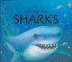 | Sharks by Phillip Clarke (2005) Usborne Publishing Ltd.  ATOS level/AR points: Not found?  Lexile: 680L  Qualitative Measure: Moderately complex, while sentence structure isn’t too complex, each page covers one topic but the sentences and paragraphs aren’t always linear and there isn’t a narrative to follow. Also, each page is organized differently in a way that would be difficult for Matthew to navigate without a guiding reader.  My thoughts: This book is one that Matthew would need to read with Mom (or another guiding reader) because it is fun! The lift-the-flaps add an element of surprise to the information being presented and an opportunity for Mom and Matthew to be surprised and involved in the text. The fun in this book comes from reading it together, and discovering the surprises behind the flaps together. In spite of its complexity, I think this is a book that Mom and Matthew could have a lot of fun reading and (to me) that makes up for the fact that it may be “above” Matthew’s reading level.

Fiction Titles

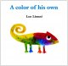 | A Color of his Own by Leo Lionni (1975) Alfred A. Knopf  ATOS level/AR points: 2.3/.5  Lexile: AD640L  Qualitative Measure: Slightly complex, each illustration reflects the text, and there are not many words per page. Sentence structure is simple and the narrative is easy to follow.  My thoughts: This simple book with beautiful illustrations and a simple but touching story provides an opportunity for Matthew to try to read on his own or to read with Mom’s guidance. I must admit I picked it because I love Leo Lionni, and when I saw he had done a book with a chameleon! It must be on the list!
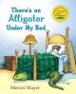 | There’s an Alligator Under My Bed by Mercer Mayer (1987) Dial Books for Young Readers  ATOS level/AR points: 2.1/.5  Lexile: 490L  Qualitative Measure: Slightly complex, the narrative is easy to follow and portrayed simply through both the text and the illustrations. There is one sentence per page that is grammatically simple, allowing the illustrations to enhance the narrative.  My thoughts: This is another book that Matthew may try and read on his own, especially since there are very few complex words (alligator may be the most complex) and each sentence builds on the story. The illustrations tell the story just as well as the words here, which Matthew may appreciate as he navigates the path to becoming an independent reader.
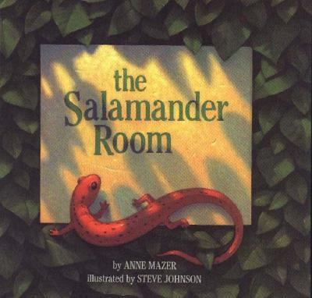 | The Salamander Room by Anne Mazer (1991) Alfred A. Knopf  ATOS level/AR points: 3.0/.5  Lexile: AD660L  Qualitative Measure: Slightly complex to moderately complex, there is about a paragraph per page, and the illustrations complement the text, but sometimes not clearly/overtly. When dialogue appears, there is no clear statement over who says what, the reader is expected to understand which statements are made by the boy’s mother, and which are made by the mother.  My thoughts: I wanted to have a bedtime story option on my list, and The Salamander Room delivers. The calming tone of the text and illustrations provide a perfect complement to cuddling up with Mom before going to sleep, while the plot (as the boy’s room transforms into a forest) will appeal to Matthew’s imagination. For me, this book isn’t about fostering Matthew’s literacy or helping him learn to read, it’s about listening to Mom read an interesting and surprisingly magical story.
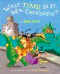 | What Time Is It, Mr. Crocodile? by Judy Sierra (2004) Gulliver Books  ATOS level/AR points: 2.4/.5  Lexile: AD940L  Qualitative Measure: Slightly complex to moderately complex, the font and text-size varies and isn’t always in a straight-line reading from left to right (however, this is often the repeated phrase, “What time is it, Mr. Crocodile?”). There is also supplementary text within the illustrations that provide additional meaning to the story, which Matthew may overlook or not understand without a guiding reader’s assistance.  My thoughts: The rhyming and humorous illustrations in this book would make it a fun book for Mom to read aloud to Matthew, and will probably capture his attention. The goofy monkeys and put-upon crocodile will also amuse Mom, as they are reminiscent of excited children and exhausted parents. There’s also an opportunity for call-response reading between Mom and Matthew with the repeated phrase, “What time is it, Mr. Crocodile?” appearing on almost every page.
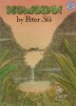 | Komodo! by Peter Sis (1993) Greenwillow Books  ATOS level/AR points: 1.8/.5  Lexile: AD780L  Qualitative Measure: Slightly complex, with only one sentence per page and large illustrations. However, some illustrations have hidden gems (such as plants in the shape of Komodo Dragons) that Matthew may not notice without Mom’s help.  My thoughts: Although the muted color tones and simple text are not overtly stimulating, the hidden images within the illustrations add a Where’s Waldo quality to the text that (with guidance from Mom, such as, “How many dragons can you find?”) will make the book more interesting for Matthew. This is another book that would make a good bedtime story, as well as one that Matthew may try to read on his own.

